Residential Living and University Housing Training Simulation Website

Design Document

Project Members:

Jillian Pulicicchio

Stephanie Canada

Sean O’Donnell

Greg Fletcher

Rebecca Hedum

Thomas Soistmann Jr.

Project’s GitHub Site: <https://github.com/gnfletcher/Senior-Project.git>

Project’s Slack’s Workspace: [https://swangworkspace.slack.com](https://swangworkspace.slack.com/)

**Design Concept:**

This project proposes to create an application to simplify the daily tasks of RLUH employees. Do accomplish this task, the project will create an interface for RA (Resident Assistants), ARD (Assistant Resident Directors) and RD (Resident Directors) to view personal information, schedule/accept programs, schedule duty responsibilities and communicate internally.

The design proposed will use a single web server, hosted by AWS, to provide the frontend and database capabilities needed and tie to external services specified later in this document.

**Web Server Infrastructure:**

The web server purpose will be a LAMP server running the Amazon AMI OS.

**Solutions Discussed:**

We have decided to interface with the Google Calendar API for all of our scheduling needs. Going hand in hand with this, we are planning to use OAuth 2.0 for any login or authentication needs. OAuth 2.0 is already used to authenticate against the Google Calendar API and can be extended to authenticate against the existing Rowan authentication system.

**Screen Mockups**:

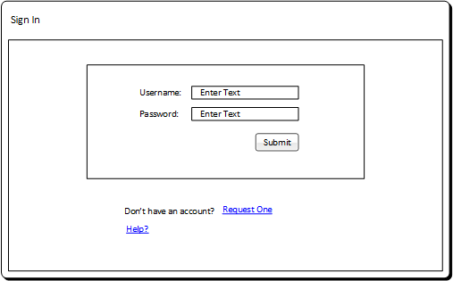

Standard Sign-in page with with the option for Resident Assistants to request access

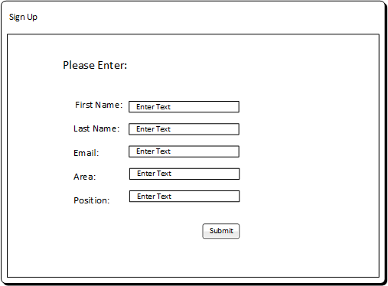

Sign-up page where Resident Assistants can request access

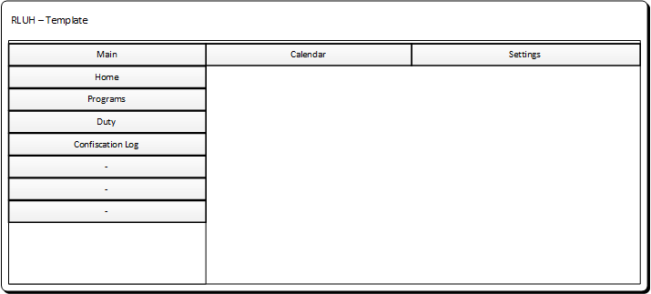

This is a basic template that will always show on the website regardless of what page it is on.

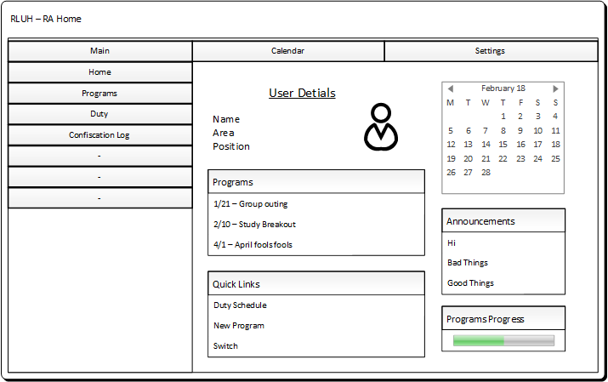

Resident Assistant home page.

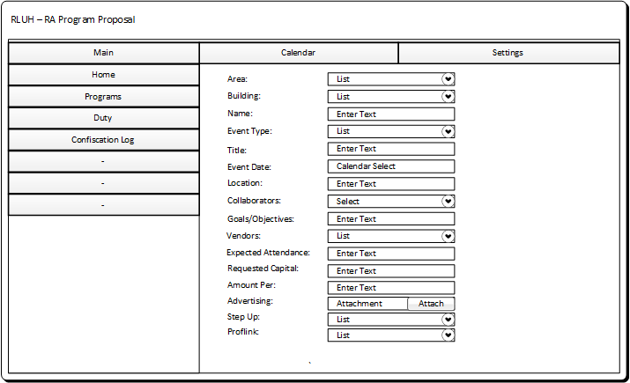

Each Resident Assistant must have a certain number of programs each semester for their residents. Resident Assistants need to fill out specific information for their program to get approved. This webpage provides the necessary information an RA would normally fill out on blackboard.

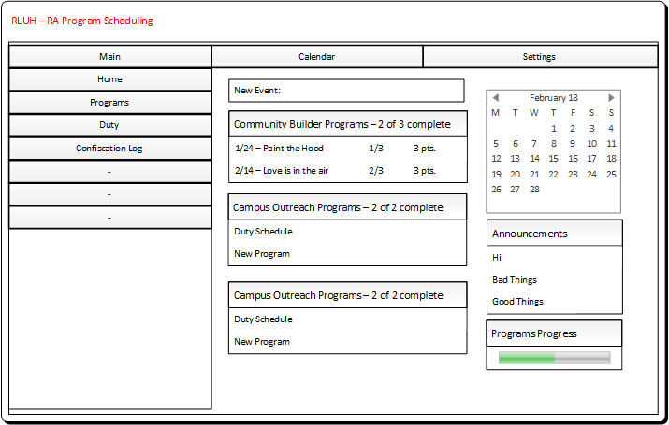

Resident Program Scheduling is a 30 point system all Resident Assistants must achieve so to meet quota. Each Resident Assistant must have at least three community builders. There are two campus outreach program each Resident Assistant must organize. Each Resident Assistant must facilitate three community meetings. Each Resident Assistant must have a set of door dec and bulletin boards. Each Resident Assistant is required to earn two points leadership initiative points. This adds up to 24 points. Resident Assistants have acquire the other 6 points by doing a cross staff program, spontaneous program, or another of the already listed programs or task.

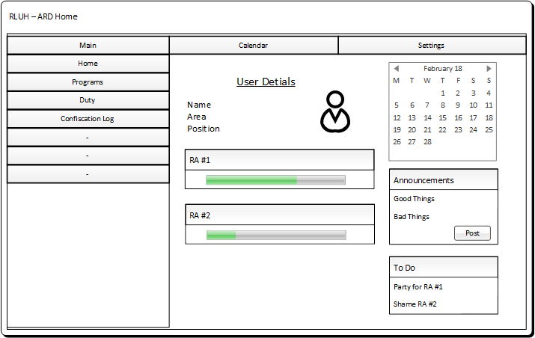

Assistant Resident Director home page

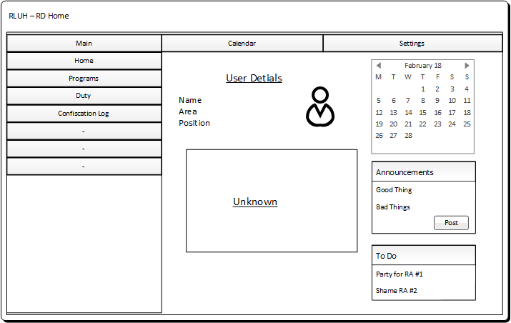

This is the Resident Director Home Page.

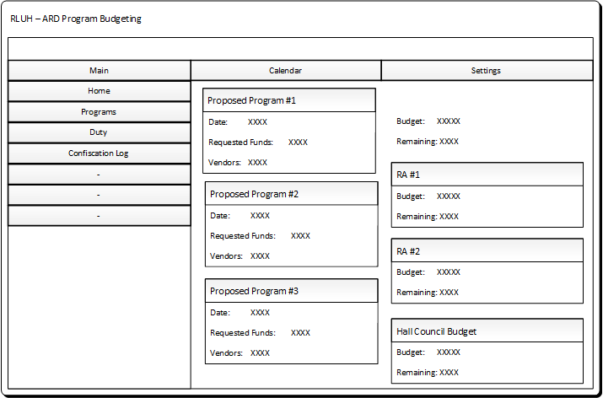

The Assistant Resident Directors will have all of the Resident Assistant Program Budgets filled in. There will also be a spot to enter the buildings budget so that the Assistant Resident Director has the remaining budget. There is also a spot for Assistant Resident Directors to enter Hall Council Budget.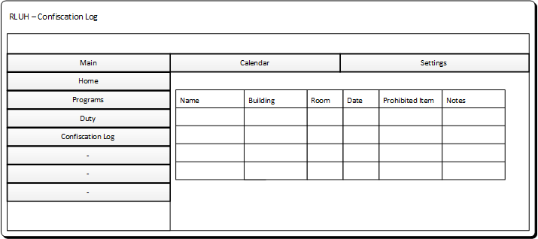

Resident Assistants and Assistant Resident Director will have access to log confiscated items.

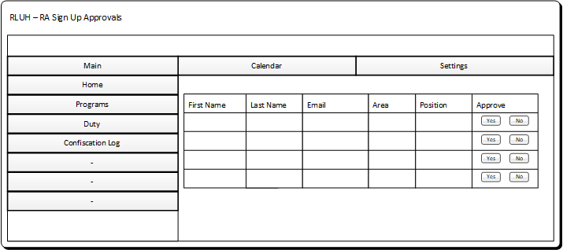

This is where the Resident Assistant will approve or deny page access request. Once all of the Resident Assistant spots for a specific area are approved, there will be no more request that will go through.

**Backend Information**:

To manage all of the data needed for this project, a MySQL database is to be implemented via phpMyAdmin. The EER diagram for our initial database schema which includes tables, their attributes, and entity relationships can be seen below.

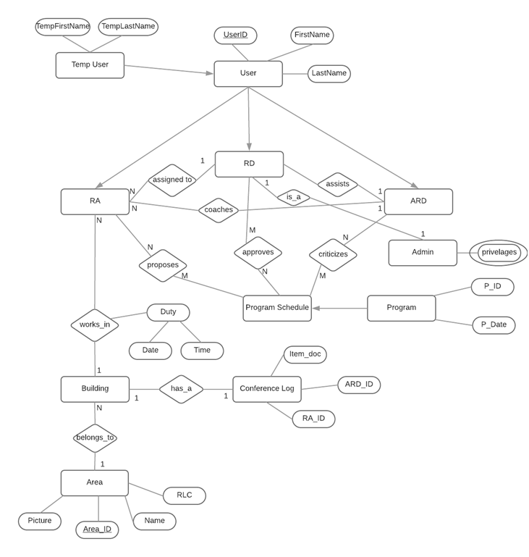

**Tasks/Goals:**

Backlog items are all listed at: <https://trello.com/swang33>